Proyecto Fase I



Gabriel Molina 1213416

Catherine López 1055816

28 de septiembre del 2020

Clases Utilizadas

* CopiaArchivo.java
* IGEstandar.java
* IFingreso.java
* ModAdmin.java
* Registro.java
* RegistroAdmin.java
* lFAdmin.java

Interfaz Grafica

CopiaArchivo.java

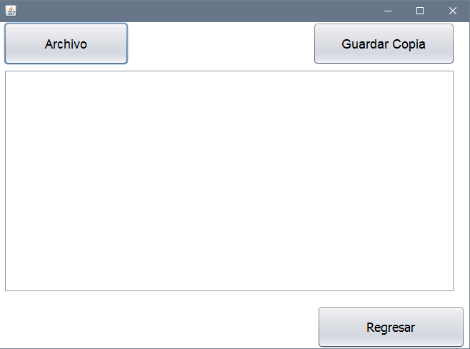

IFEstandar.java

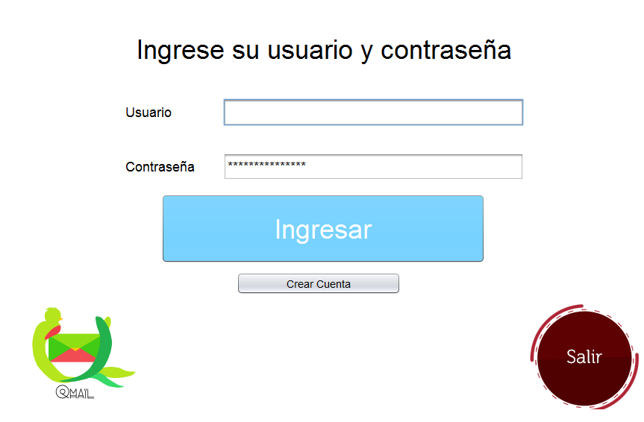

IFingreso.java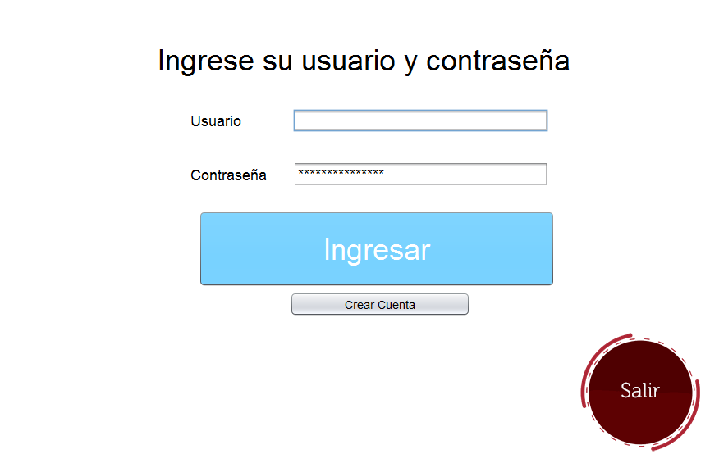

ModAdmin1.java, Registro.java, RegistroAdmin.java

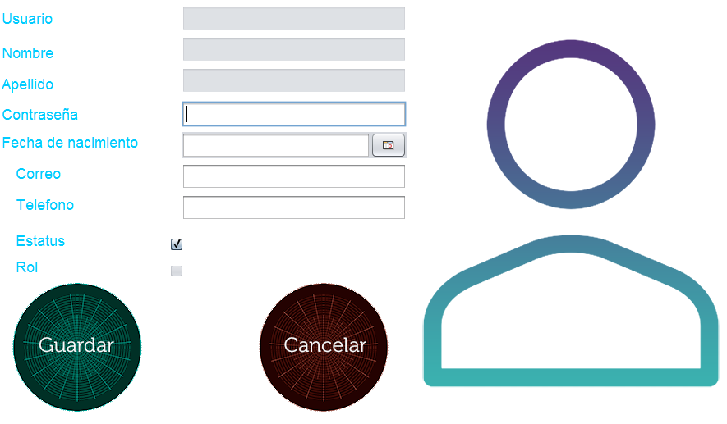

lFAdmin.java

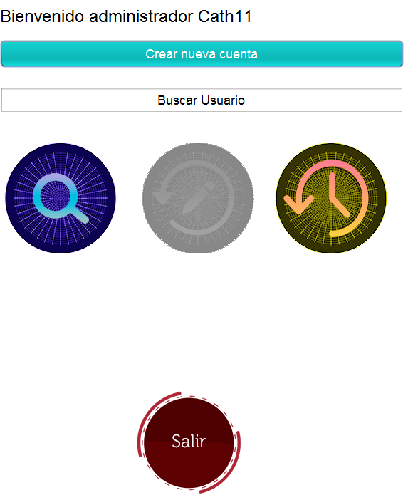

Resumen

El objetivo principal del proyecto es poner en practica los conocimientos de rutas, almacenamientos y archivos.

Como objetivos debe realizar el ingreso de usuarios y crear archivos de texto con la información almacenada, como por ejemplo en el caso de los usuarios debe guardar una base de datos en un archivo txt llamado usuarios, donde se almacenan toda la información del usuario que se ha creado.

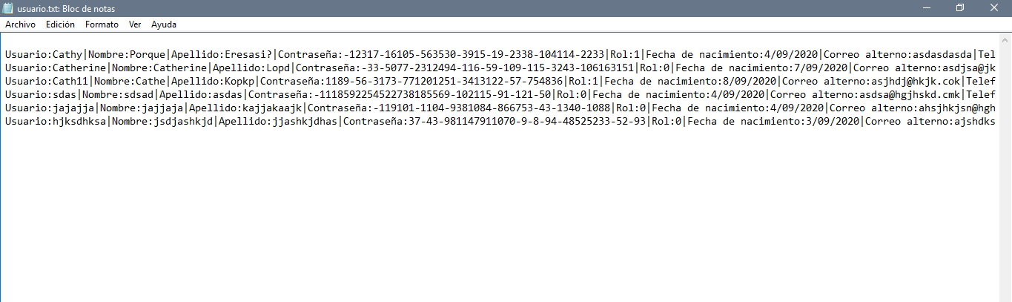

Metodos,Clases y Variables

## A

**AbrirArchivo(File)** - Method in class CopiaArchivo

## C

**cifra(String)** - Method in class IFingreso

**cifra(String)** - Method in class ModAdmin1

**cifra(String)** - Method in class Registro

**cifra(String)** - Method in class RegistroAdmin

**controlesAct(boolean)** - Method in class IFingreso

**CopiaArchivo** - Class in <Unnamed>

**CopiaArchivo()** - Constructor for class CopiaArchivo

**cuenta** - Static variable in class IFingreso

**cuentaC** - Variable in class ModAdmin1

**cuentaC** - Variable in class Registro

**cuentaC** - Variable in class RegistroAdmin

## D

**descifra(byte[])** - Method in class IFingreso

**descifra(byte[])** - Method in class ModAdmin1

**descifra(byte[])** - Method in class Registro

**descifra(byte[])** - Method in class RegistroAdmin

## G

**getObj(String)** - Static method in class RegistroAdmin

**getObj(String, boolean)** - Static method in class ModAdmin1

**GuardarArchivo(File, String)** - Method in class CopiaArchivo

## I

**IFEstandar** - Class in <Unnamed>

**IFEstandar(String)** - Constructor for class IFEstandar

**IFingreso** - Class in <Unnamed>

**IFingreso()** - Constructor for class IFingreso

## L

**lFAdmin** - Class in <Unnamed>

**lFAdmin(String, boolean)** - Constructor for class lFAdmin

## M

**main(String[])** - Static method in class CopiaArchivo

**main(String[])** - Static method in class IFEstandar

**main(String[])** - Static method in class IFingreso

**main(String[])** - Static method in class lFAdmin

**main(String[])** - Static method in class ModAdmin1

**main(String[])** - Static method in class Registro

**main(String[])** - Static method in class RegistroAdmin

**ModAdmin1** - Class in <Unnamed>

## O

**opciones()** - Method in class ModAdmin1

**opciones()** - Method in class Registro

**opciones()** - Method in class RegistroAdmin

## R

**Registro** - Class in <Unnamed>

**Registro(boolean, String)** - Constructor for class Registro

Creates new form Registro

**RegistroAdmin** - Class in <Unnamed>

**rol** - Variable in class ModAdmin1

**rol** - Variable in class Registro

**rol** - Variable in class RegistroAdmin

## U

**usuarioMod** - Variable in class ModAdmin1

**usuarioMod** - Variable in class RegistroAdmin

## V

**valorRol** - Static variable in class IFingreso

Creates new form IFingreso

**Verificar(JTextField, int, int)** - Method in class ModAdmin1

**Verificar(JTextField, int, int)** - Method in class Registro

**Verificar(JTextField, int, int)** - Method in class RegistroAdmin

**VerificarContraseña()** - Method in class ModAdmin1

**VerificarContraseña()** - Method in class Registro

**VerificarContraseña()** - Method in class RegistroAdmin

**VerificarUsuario()** - Method in class ModAdmin1

**VerificarUsuario()** - Method in class Registro

**VerificarUsuario()** - Method in class RegistroAdmin